

**NATIONAL UNIVERSITY OF SCINCES AND TECHNOLOGY**

**“FUNDAMENTALS OF PROGRAMMING”**

**ASSIGNMENT # 03**

**SUBMITTED TO: Sir AFFAN**

**SUBMITTED BY:MUHAMMAD HAMAD ARSHAD**

**CMS:481644**

**SEC-A ME-15**

# TASK NO1:

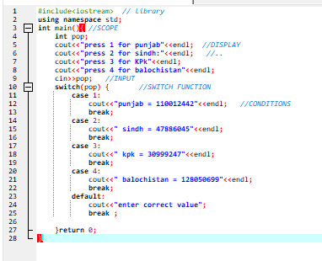

RESULT:

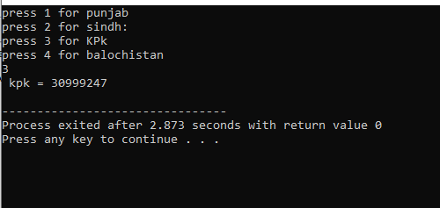

## TASK NO 2:

RESR

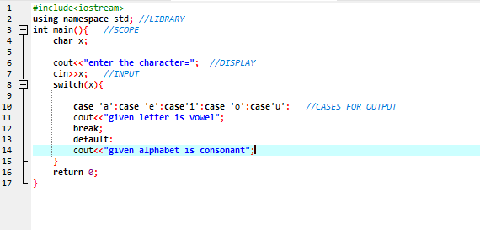RESULTS:

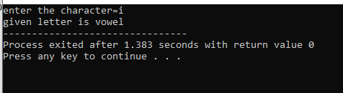

# TASK NO 3:

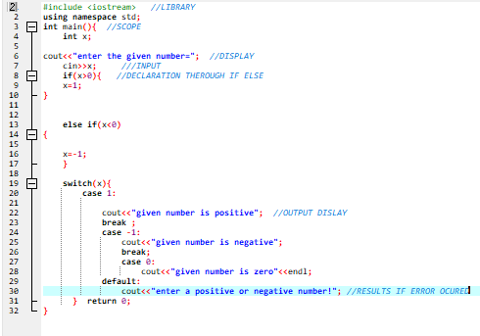

# RESULT:

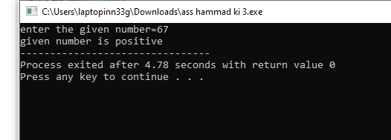

# TASK NO 4:

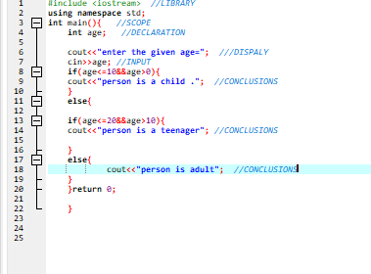

# RESULTS:

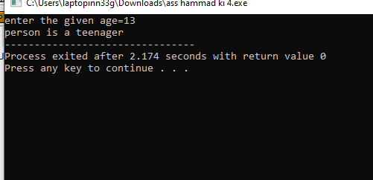

# TASK N0 5:

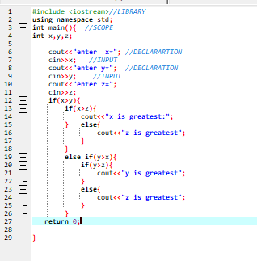

## RESULTS:

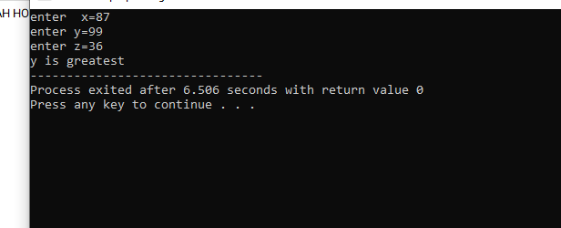

# TASK NO 6:

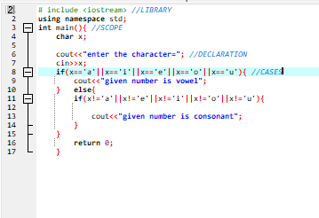

# TASK NO 6:

